Observers: A. Moors, P. Sockness Survey Results: Pair Confirmed, non-nesting
Mountain Range: Huachuca
Quad map name(s): Miller Peak, AZ General habitat: riparian/mixed conifer
Visit#: NS2 DS3
Sunrise or Sunset Time: 0527
Times For: | Start (24-hr) | End (24-hr) | Total  (~ ¼ hour)

Hike-in:
Survey: | 0410 | 0630 | 2.5
Hike-out: | 0630 | 0706 | 0.5
Owl hooted at parking area so counted hike-in as survey time
Weather: | Survey
Weather: | Start | End
Wind (range mph): | 0 | 0
Clouds (%): | 0 | 0
Precip: | 0 | 0
Temp (F): | 50 | 54
Mexican Spotted Owl Locations are reported in table below
 |  |  | Response |  | NAD83
SPP | Sex | Age | Type | Time | UTM-E | UTM-N
STOC | M | U | A | 0410 | 569999 | 3474163
STOC | M | U | AV | 0444 | 569067 | 3474173
STOC | M | A | V | 0530 | 568904 | 3474109
STOC | F | S | V | 0530 | 568904 | 3474109
Use the following codes:
SPP = STOC for Mex Spotted Owl
Sex: F = female, M = male, U = unknown
Age: A = adult, S = subadult, Y = branched
young; H = hatchling or nestling
Response Type: V = seen, A = heard,
N = none, NEST = Nest found,
D = dead owl found
Time = 24 hr time of response

Mousing Used? Y Number Used: 3

I = Ignores;
 | Fates of Mice Initially Taken By The
Mouse # | Male | Female | Unknown
1: | F | A?
2: | A
3: | C?
4:
5:
6:
C = cached;
F = given to female out of nest;
M = given to male;
Y = given to young;
N = taken to nest or to female in a nest;
A = eaten by individual that took the mouse;
L = left with mouse and fate unknown;
G = mouse got away;
H = held for 1 hour.

Nest located? N Evidence used: Day roost located? Y

Other raptors seen or heard during survey: RED-TAILED HAWK NESTING, GREATHORNED OWL CALLING

Comments:

Started in new parking area for trailhead (they moved the parking area by about 40 m down canyon, not sure why).

As I was getting my pack ready I heard a male STOC calling nearby. I stopped and listened for a few minutes, but heard nothing, so I hooted two four-note series and he called back. Bearing 181 degrees and approx. 150 to 200 m away. His fourth note seems to drop and slur. I wasn’t sure if this was a new bird or the same male from Hunter Canyon, but decided to hike into Hunter canyon and survey there and leave this bird alone. However, as hiking into Hunter canyon along the old road bed, it was clear the male from the parking area was moving across the face of the ridge toward the roost area in Hunter Canyon (see yellow dashed line on map). So I believe this was the Hunter Canyon male. I did not call after leaving the parking lot. So he was moving toward canyon and calling on his own.

When I reached the first area of firs in Hunter Canyon I could hear male doing the monkey call (agitation hooting) across creek from me. I squeaked and he flew to me. It was still dark out, so I stalled a little by showing mice but not making them available to him. Want to get more light to see where he goes, but don’t want him to lose interest. After a few minutes I decided to put mouse 1 out and male took it quickly and flew to female and gave it to her. Could hear her chitter and hoot. Not sure if she ate it or not, but I assume so. Then male flew quickly right back to me. I put out 2nd mouse and he took it quickly and flew to nearby branch in fir tree. He fiddled with it as if unsure what to do with it. He also seemed VERY nervous. He would frequently look around as if being hunted and worried of impeding attack. There was a great horned owl calling upslope far away but the STOC doesn’t seem to be worried about that sound. Not sure what has him on edge. He fiddled with mouse for a few minutes and then eventually ate it.

I am still hoping for more light to see better in case he flies away. Waited a little before putting out third mouse. He grabbed it quickly and flew to farther tree and called. Female called from much farther up canyon, so I packed up and moved to be in between the two. Male and female call back and forth and after quite awhile the female flies to the male but he does NOT give her the mouse and instead flies away with it. Female head up canyon, male has crossed it and headed more upslope to east. I follow the male and can hear him hooting and see him holding 3rd mouse. Still dark out but in binoculars I can see a little better. He flies around with mouse….maybe going to cache it? Eventually he flies into drainage toward where female is calling. I lose the pair for awhile and so I played the slur call on my phone…no reply. However, after a few mins, the male 3 note hoots about 15 yds up drainage from me and then female replies with four note hoot about 15 yds down drainage. He flies to her. Probably still has mouse but not sure, didn’t see it. He perches right next to her, but don’t see him give her a mouse. Instead he preens her head feathers and they chitter back and forth contentedly.

I wanted to wait for more daylight before approaching them, so they won’t flush. So I left Pete to watch the pair while I went up to retrieve the MP3 recorder I left at the upper fir area. I got it at 0541 and was back down to Pete at 0555. I took several minutes to write up notes and then we went down toward their roost. They are in a small silver leaf oak that arches out toward drainage. I can’t approach under the roost to look for sign or measure it for fear they will flush. They are only about 10 feet above steep slope that leads to drainage. The oak is about 25 feet tall but doesn’t grow upward, instead it arches out toward drainage, so that at it’s tallest, it’s maybe only 15-20 feet above ground. Slope they are on is very steep (56 degrees) but only 10 yards up from main drainage bottom. Roost tree is approx. 8 inches in diameter. Owls perched on branch coming off bole at 100 degrees aspect. Slope aspect is 177 degrees. Across from them is what I consider a better roost tree. It’s a small but well shaded fir tree that I found pellets and whitewash under on DS1. Not sure if where pair is roosted now is normal roost or if they roosted there to get away from me. However, they look very comfortable where they are as if they have used it many times.

Male is unbanded adult. Female has white pointed tail feathers of a 2nd year subadult. Based on behavior I conclude they are not nesting this year.

Took pics and then left area about 0630….picked up recorder5 on way out. Back at jeep at 0706

Recorders are shown on map as waypoints that don’t have labels, would have made map too cluttered to label. Upper recorder was at 568625, 3473999. Lower recorder at 569005, 3474159. Later analysis of recorder files showed both recorders were working from April 25 about 0650 hrs to May 7 0600hrs. Both recorders confirmed the pair and had STOC calling on 12 of the 13 days they were out recording.

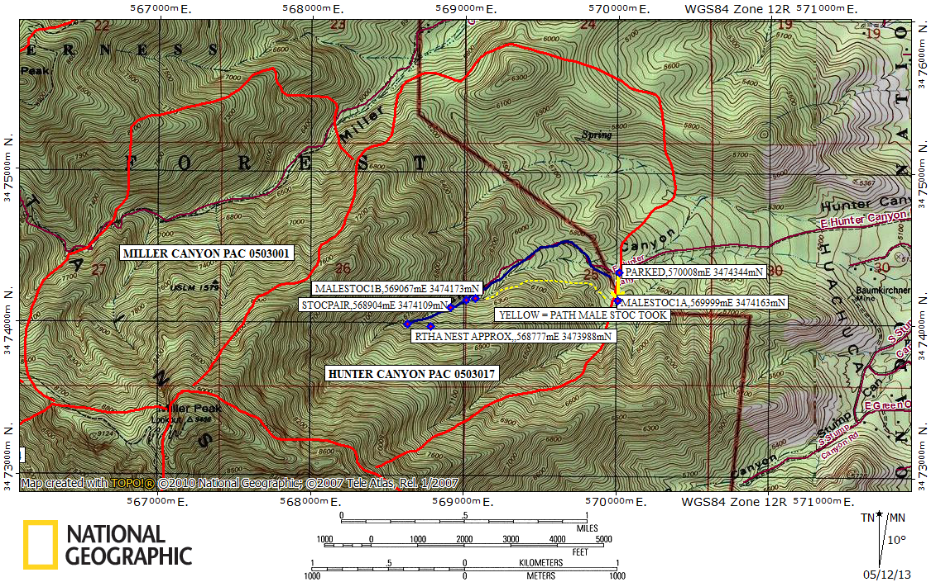

Blue line = path walked, Red line = PAC boundaries

Yellow arrow = compass bearing to owl. Yellow dashed line indicates approx path the owl took from parking area to roost. Could hear him hooting across face of slope as we hiked into canyon

